**Arab Academy for Science, Technology, and Maritime Transport College of Computing and Information Technology**

**Smart Village**

Boulevard Mall

**Software Engineering Project**

A Thesis submitted in partial fulfillment of the requirements of Software Engineering Project

by

### **Abdelrahman Mohamed Mahmoud 221027770**

### **Omar Hesham Hamed Ali 221027535**

### **Nour Mohamed Mahmoud 221027637**

### **Marwan Yasser Mohamed 221027664**

College of Computing and Information Technology, AASTMT, 2023

Supervised By

Eng. Ahmed Gamil

Cairo, 2024

# Abstract

This Software Requirements Specification (SRS) outlines a mobile mall management system designed to streamline mall operations and enhance the customer shopping experience. The system caters to various stakeholders, including mall administrators, tenants, and customers. Key functionalities include browsing stores and services, managing inventory, real-time traffic estimation, and personalized recommendations. The SRS prioritizes user-friendliness, security, and scalability to ensure a seamless experience for all. This innovative system aims to revolutionize the traditional mall experience by offering a user-friendly mobile platform with integrated functionalities.

**Chapter 1**

**Introduction**Our Mall Management System is designed to optimize mall operations and enhance the customer shopping experience. It caters to various stakeholders, offering features like inventory management, order tracking, maintenance scheduling, and financial reporting. The system provides a seamless interface for customers and a comprehensive dashboard for tenants and management. This SRS document outlines the system's functionalities and specifications, serving as a guide for developers and stakeholders. Our future vision includes the integration of advanced technologies like AI for further enhancements.

## Motivation

The motivation behind the system mall project to simplify the shopping experience for consumers by modernize traditional mall management methods By leveraging technology. The project aims to bring a variety of shops and services under one digital roof, making it easier for consumers to find, compare, and purchase products or services.

## Problem Statement ا

The current online shopping experience is fragmented, with consumers needing to visit multiple websites or applications to complete their shopping. This leads to a time-consuming experience. Each platform has its own interface, payment system, and delivery method, which can be confusing and time-consuming for the customer. price comparison becomes a tedious task as customers must manually check each platform for the best deal.

The absence of a unified shopping platform also poses challenges for businesses. They need to maintain a presence on multiple platforms, each with its own set of rules and fees, which can be costly and complex.

## Objectives

We need to solve this problem consolidate multiple shopping platforms into one with a smooth and easy-to-navigate interface to significantly enhance the user experience and integration of various services, including payment systems, delivery services, and customer support while ensuring the security of customer data.

provide support for businesses, making it easier for them to manage their online presence, and reach more customers.

## Problem Complexity

tenant management, visitor tracking, marketing automation, and data analytics. Additionally, the system must cater to the diverse needs of various stakeholders, including mall administrators, tenants, and visitors, while ensuring scalability and security by managing a vast array of products and services.

## Constraints

**Solution Constraints**: the system will be available only on smart phones with OS (Android and Ios) for the stakeholders to be cheaper and availability for all.

**Deadline**: The project should be completed within a year.

**Financial Budget**: The estimated budget for the project is $500,000.

**Current System Constraints**: Finding a parking spot at the mall right now is a hassle. like it's pretty crowded, which can be frustrating for customers.

## Standards

The mall system will adhere to industry data security standards (such as PCI DSS for payment processing), usability guidelines, and regulatory compliance (such as GDPR for data protection).

## Thesis Organization

**Vision**: The vision of the system mall project is to revolutionize the online shopping experience; we aim to contribute to the understanding and evolution of online shopping platforms. The aspiration is to inspire further research, fostering innovation in e-commerce.

**Mission**: The mall management system handles daily operations such as inventory and order management, maintenance scheduling, security monitoring, financial tracking, customer service, marketing campaigns, and tenant management.

## Feasibility Study and Business Canvas

|  |
| --- |
|  |

**Chapter 2**

## Similar Systems

|  |  |
| --- | --- |
| Name | Mall of Arabia |
| Description | is a comprehensive software solution designed for the management and operation of Mall of Arabia, one of the largest malls in Egypt. It offers a wide range of features |
| main function | is to optimize mall operations by automating processes such as lease administration, maintenance scheduling, and customer relationship management. |
| Input and Output of System | Input: tenant contracts, maintenance requests, sales data, customer feedback.  Output: lease agreements, maintenance schedules, marketing reports, visitor analytics, and personalized offers |
| technology used | While specific technologies are not disclosed utilizes cloud-based technologies for scalability and accessibility, along with IoT sensors for data collection. It may also incorporate AI for predictive analytics |
| results for the system | System has led to improved operational efficiency, increased tenant satisfaction, and enhanced visitor experience so the mall has become a major landmark in the city |
| advantage | Comprehensive feature set tailored for mall management needs and Scalable architecture supports future growth |
| disadvantage | Initial setup costs may be significant Ongoing maintenance and updates are necessary to ensure system performance this will be costly |

## Similar Systems

|  |  |
| --- | --- |
| Name | Arkan Mall |
| Description | software aims to enhance customer experience, and manage various aspects of mall management and is located in 6th October city |
| Main Function | Arkan Mall likely serves as a retail and office space hub, offering a variety of services to visitors and tenants. |
| Inputs and ouputs | system will receive inputs such as sales data, tenant information, and customer feedback Outputs include financial reports, tenant agreements, and customer notifications |
| Technology Used | Arkan Mall has embraced sustainable technology, running entirely on solar power. Database Management Systems that stores and retrieves data efficiently.  Point-of-Sale (POS) Systems that Handling sales transactions |
| Results for the System | successful operations, high tenant occupancy rates, and positive customer reviews |
| Advantages | strategic location, mixed-use design, and commitment to sustainability |
| Disadvantages | might face challenges related to maintenance costs, market dynamics, and competition. |

**Chapter 3**

## Software Process Models

As a System Administrator, I want to monitor system performance so that I can ensure the system is running smoothly and efficiently.

As a System Administrator, I want to backup and restore system data so that I can prevent data loss in case of a system failure.

As a System administrator, I want to schedule and assign maintenance tasks to maintenance staff so that facility issues can be addressed promptly and efficiently.

As a admin, want to Analyze user data for personalized product filtering so that I can show him his trend only

As a Customer, I want to browse through the wide range of products and if the product is finished or there is a limited number it left and when it will be available so that I can find the items I need.

As a Customer, I want to compare prices in all stores\ services and offers so that I can find the best deal.

As a Customer, I want discounts based on my preferences and past purchases and know the events so that I can enjoy a more tailored shopping experience and find relevant deals easily.

As a Customer, I want to leave a review for the products I purchased so that I can share my experience with other customers.

As a Customer, I want to Mall map so that I can reach my destination.

As a Customer, I want to know the traffic in the so that I can enjoy easier shopping.

As a Customer, I want access to a chatbot for common questions so I can know the answer of my questions quickly.

As a customer, I want Know the event calendar and add the event to my personal calendar so that I can know the event and remember it

As a customer I want to Movie showtimes, ticket pricing, and reservations so that I can enjoy with the move simply

As a customer, I want when I play make score on the application so that I can replaced it with games, a cash return on your account, or a opportunities to play for free depending on the value of the score

As a customer I want to record inbody data on the system so that I canknow your daily needs of protein, calories … etc., to be healthy.

As a customer I want know the empty space in the garage and reservation it so that I can bark my car easy

As a customer I want to know price, offers, and available equipment so that I can equipment

As a customer I want to track my order if he ordered it from app so that he can know when it will be finish

As a tenant, I want registering lease contract so that I can access on the mall system

As a tenant, I want to access sales reports and analytics for my store so that I can improve profitability.

As a Tenant, I want to list my products and adjust its price on the platform so that I can reach a wider customer base.

As a Tenant, I want to manage my product listings so that I can keep my inventory up to date.

As a Tenant, I want to Know the all the sales and offers of my competitors in my store category so that I can keep pace with competitors.

As a maintenance staff member, I want to receive automated notifications for maintenance requests and access detailed information about the issue and its location so that I can respond promptly and resolve the issue efficiently.

As a Maintenance Staff, I want to log my maintenance activities in the system so that I can keep track of all the tasks performed and the resources used.

As a member of the marketing team, I want to analyze visitor traffic patterns and trends so that I can develop effective marketing campaigns to attract more customers.

As a Security Personnel, I want to monitor security cameras through the system so that I can ensure the safety and security of visitors and tenants.

As a Security Personnel, I want to log any security incidents in the system so that I can provide detailed reports to the management or can use them as forensic evidence.

As a Financial Controller, I want to access sales and expenditure data so that I can monitor the mall's financial health and make informed decisions.

As a IT, I want to maintain system security, support maintenance and assist in data analyses so that I can insure system availability and performance.

As a IT, i want to see the basic layout of the map so that i can know if it will work

As a IT, I want to testing and bug fixes so that i can insure every is working

As IT I want to User Interface (UI) enhancements and polish so that I can customer satisfaction

## Functional Requirements

**(Core Functionality):**

* User Management: Sign-up/Login (email/phone), password change
* Lease Management: Tenant registration (basic info)

**(Mall Exploration):**

* Browsing stores/services by search and category
* Interactive Map (basic layout)

**(Engagement & Feedback):**

* User ratings & reviews for stores, services, products
* Personalized recommendations based on purchase history.

**(Promotions & Sales):**

* Displaying special offers and discounts
* Recording sales transactions (basic data)

**(Inventory & Maintenance):**

* Real-time Product Availability Status
* Log and manage basic maintenance requests.

**(Navigation & Traffic):**

* Enhance Interactive Map with user location display.
* Implement traffic estimation based on sales data.

**(Advanced Features 1):**

* Events calendar with basic functionalities
* Garage parking space availability display

**(Entertaining):**

* Magic Planet: App-based score system for rewards
* Movie showtimes, ticket pricing, and reservations

**(Health and food):**

* Food order tracking with estimated delivery time
* Display pricing, offers, and available equipment

**(Personalization & Integration):**

* Analyze user data for personalized product filtering.
* Integrate event calendar with personal calendar apps.

**(Advanced Features 2):**

* Chatbot for simple FAQs and customer service escalation
* Inbody data recording and fitness recommendations (Gym)

**(Refinement & Testing):**

* System-wide testing and bug fixes
* User Interface (UI) enhancements and polish

## Description Functional Requirements

-Lease Contract Registration by gathering tenant information, creating lease agreements, execute them, and maintain organized records.



-The user should be able to sign up or log in and change password by his email or phone number.

-Browsing the stores and services of mall by search so they can easily find the store they want easily and browsing about the products or brand and where they can find it.

-Special offers and discounts for consumers based on their purchases and trends.



-The user can rate and give feedback about sales, stores, services, prices, etc.

-Making a census of sales and purchases by recording sales transactions and generating reports and tracking stock levels and restock inventory.

-Display products in all stores and services and make the user able to compare prices in all stores and services.

-The customer can know if the product is finished or not or if there is a limited number of the product left and when it will be available.

-Sending alarms to maintenance workers to notify them if there is problems in the mall will include where the problem is and what the problem is and I want to log them maintenance activities in the system.

-Analyzing the user directions and interests to filter the products that he is interested in to show up first in the app and to see which stores are the most visited by consumers by analyzing sales.

-An interactive map It shows the user's location in the mall and determines his destination for easy navigation in the mall

-Make the user able to know the traffic in the places he is looking for by analyzing the surveillance cameras and making the system capable of traffic forecasting through sales statistics.

-providing an events calendar that includes events, offers, and promotions, and allowing users to add events to their personal calendar directly from the application.

-Make the user able to know the empty spaces in the garage and reserve them through the application.

-The user's ability to track the status of his meal and the remaining time if he orders food from within the application.

-Viewing, rating, and trailer the films shown, displaying the prices of ticket categories, and the ability to reserve them and specify your seat.

-In the Magic Planet, traditional profit cards can be replaced with a score on the application, and the score can be replaced with games, a cash return on your account, or a opportunities to play for free depending on the value of the score.

-Displaying prices and offers for the gym and available Machine, and the ability to record inbody data on the application to know your daily needs of protein, calories … etc., to be healthy.

-Chatbot to respond to common and frequently asked questions, and if a satisfactory answer is not found, the customer is transferred to customer service.

## Non-functional Requirements

**Product Requirements:**

Scalability:

- Implement a cloud-based infrastructure with auto-scaling capabilities to handle a varying number of clients (100,000 to 1 million).

- Use load balancers to distribute traffic evenly across servers.

- opt for a microservices architecture to allow for independent scaling of different components.

Security:

- Encrypt sensitive data using industry-standard encryption protocols ( AES-256).

- Integrate OAuth 2.0 or JWT for secure authentication.

- Perform regular penetration testing to identify and patch vulnerabilities.

- Implement two-factor authentication (2FA) for user logins.

- Set a session timeout of 30 minutes on payment pages to protect user data and optimize server usage.

Reliability:

- Deploy redundant servers and databases across multiple availability zones.

- Utilize transaction monitoring tools to ensure system integrity and quick recovery from failures.

- Establish SLAs for uptime (99.9%) and response times ( 200 ms).

- Implement a system refresh rate of every 5 seconds for optimal performance.

- Ensure data transfer speeds of at least 10 Gbps.

- Guarantee that all system functions respond within 0.5 seconds.

Compatibility:

- Conduct thorough testing for cross-browser compatibility on Chrome, Firefox, Safari, and Edge.

- Test the app on a variety of devices and screen resolutions.

- Apply responsive design principles to ensure the app adapts to different devices.

User-Friendly:

- Choose a color scheme that is visually appealing and comfortable for users.

- Design an intuitive user interface with straightforward navigation.

- Include accessibility features like screen readers and keyboard navigation.

- Support multiple languages and currencies for a diverse user base.

- Perform localization testing to ensure translations are accurate and culturally sensitive.

**Organizational Requirements:**

- Follow data privacy laws like GDPR.

- Keep logs of user actions for compliance.

- Regularly audit to stay in line with industry standards.

- Encrypt data and have a clear policy on how long we keep user information.

- Regularly back up data and have a disaster recovery plan.

- Provide detailed documentation for developers and helpful guides for users.

Cost Management:

- Monitor costs and ensure eco-friendly tech leads to savings and environmental benefits.

Training:

- Train mall staff on environmental best practices.

Security Protocols:

- Use cameras, security personnel, and bag checks to keep everyone safe.

- Follow the law on public space security.

Environmentally Friendly Operations:

- Use lighting that adjusts to natural light and natural cooling methods.

- Install water-saving taps and fix leaks quickly.

Teleportation Services Integration:

- Partner with transport companies for easy mall access.

- Integrate these services into our app or website.

**External Requirements:**

Improving Usability:

- We'll regularly test the app with real users to make sure it's easy to use.

- The app will adjust to fit different screens, so it works well on any device.

Localization:

- We'll make sure the mall respects local religious and cultural customs, like prayer times and fasting during Ramadan, and we'll have places to pray in the mall.

- Our food courts will offer a variety of foods, including options for those who follow halal diets.

- We'll plan events and adjust mall hours to celebrate Egypt's holidays and traditions.

Compliance with Government Regulations:

- We'll keep up to date with laws that affect malls and stores, like building codes and business licenses.

- We'll make sure we're doing things right when it comes to taxes and selling products from other countries.

Community Engagement:

- We want to be good neighbors, so we'll work closely with local leaders and groups.

- We'll get involved in community projects, support charities, and help with efforts that make the area better.

Policies and Client Rights Saving Rules:

- Our return and exchange policy will be easy to understand and follow Egypt's consumer protection laws.

Price Transparency:

- All our prices will be clearly shown, including any taxes or extra fees, to avoid any surprises.

Privacy Policy:

- We'll have a privacy policy that explains how we handle personal information, following Egypt's data protection laws.

- We'll only collect personal info if customers agree, and they'll have control over their data.

Health and Safety Measures:

- We'll keep the mall clean and safe, following health guidelines, including using hand sanitizers and cleaning often.

Accessibility Standards:

- We'll make sure the mall is accessible to everyone, including those with disabilities, by providing things like ramps and elevators with Braille.

Ethical Business Conduct:

- We're committed to doing business the right way, treating everyone fairly, and providing a safe and fair workplace.

## UML Diagrams

## USE CASE Diagram:

|  |
| --- |
|  |

## Class Diagram

## Activity Diagram

|  |
| --- |
|  |

## sequence diagram

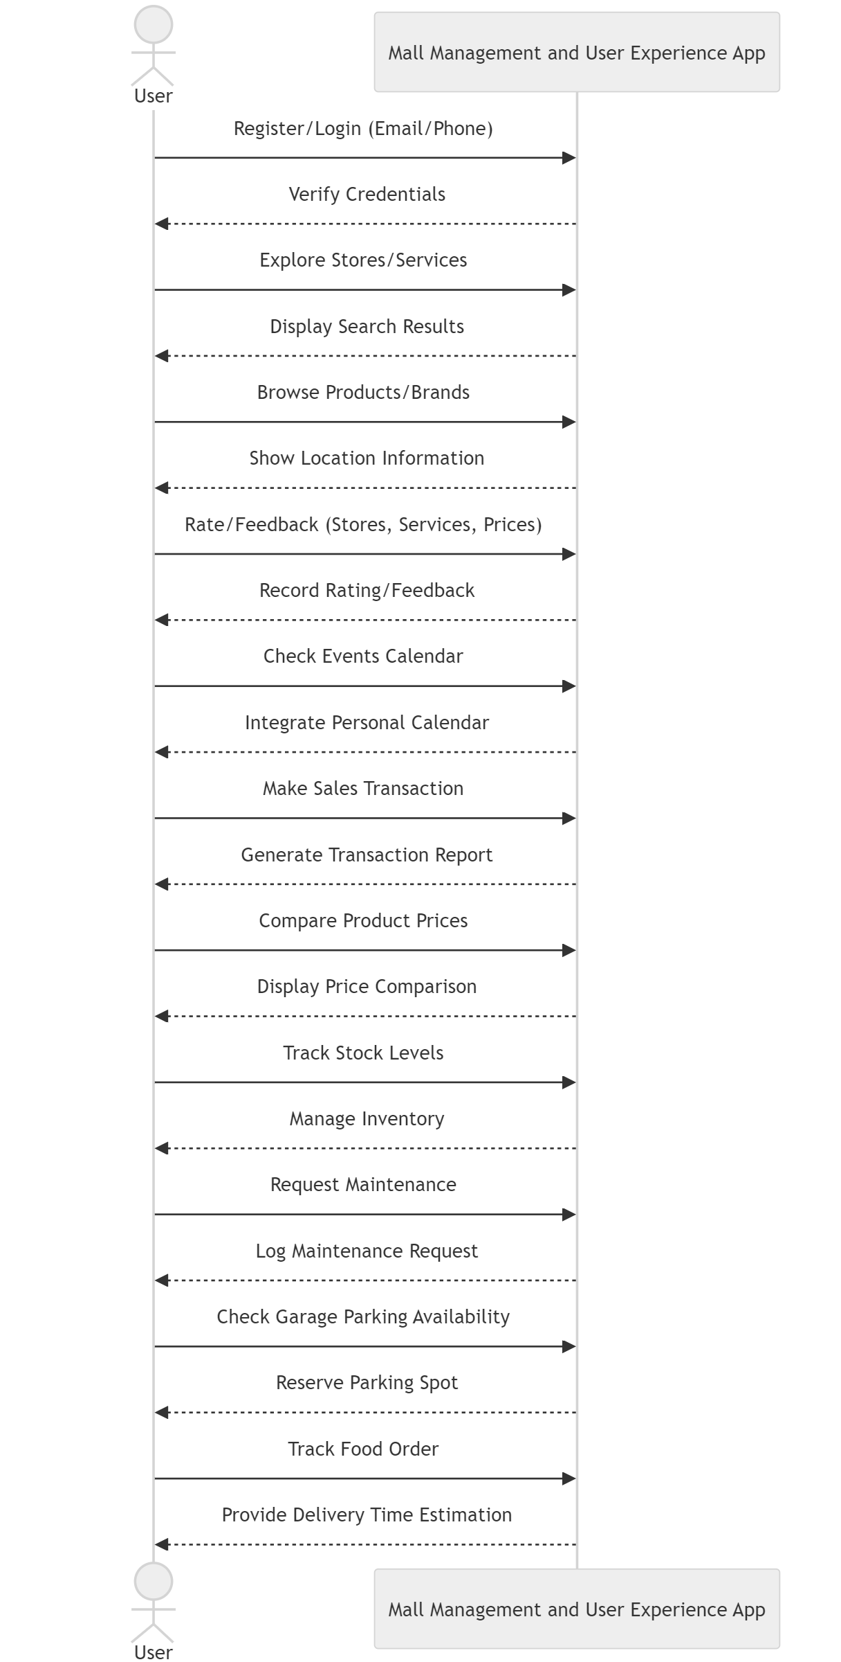

## State diagram

## DFD diagram Level 0

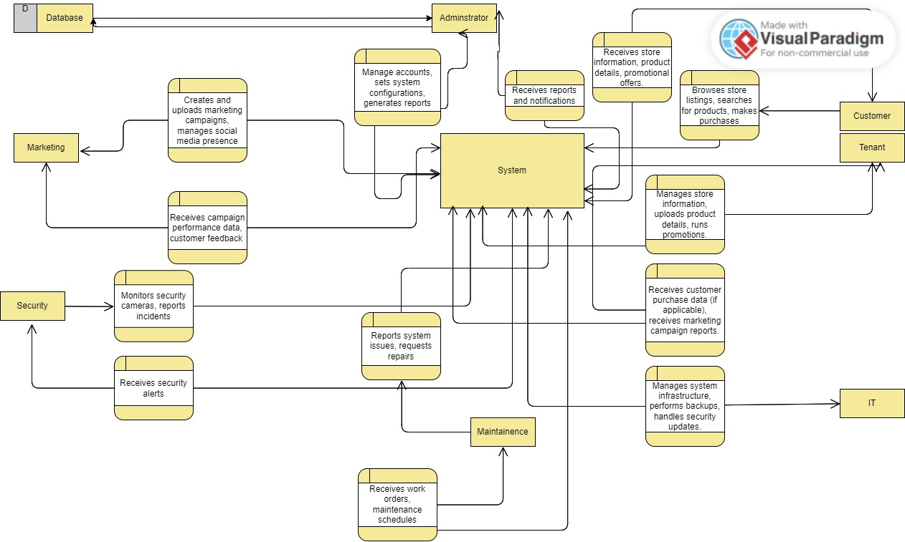

**Chapter 4**

## Technologies and Tools Used

**For Making the App:**

- We'll use React Native and Flutter, which are like Swiss Army knives for building apps that work on both iPhones and Android phones.

- For maps and getting around, we'll tap into Google Maps, which is like having a GPS in your pocket.

**For the Behind-the-Scenes Tech:**

- We'll write the code in Java and Python, which are like ABCs for computers to understand what we want them to do.

**For Storing Information:**

- We'll use SQL databases like a big filing cabinet for all the structured stuff.

- NoSQL databases will be our go-to for when we need to be a bit more creative with how we store things.

**For Keeping Everything Running Smoothly in the Cloud:**

- We'll use Amazon Web Services, Microsoft Azure, and Google Cloud, which are like virtual power plants keeping our app running no matter how many people use it.

**For Extra Features:**

- We'll manage all the ways our app talks to other services with tools like Apigee.

- For shopping and payments, we'll make friends with Stripe and PayPal, and local options like Fawry, Etisalat Cash, and Vodafone Cash, so it's super easy to buy stuff.

- To understand what people, like in the app, we'll use Google Analytics, which is like having a crystal ball for user behavior.

**For Chatting with the App:**

- We'll create a chatbot using Dialog flow or Amazon Lex, which is like having a robot friend in the app to answer your questions.

**Keeping Everything Safe:**

- We'll protect everyone's information like it's a treasure chest, following all the important rules and using strong passwords.

- For logging in, we'll make sure it's as secure as a bank vault with extra checks to confirm it's really you.

**Looking Ahead:**

- We're thinking about using AI, which is like having a smart assistant, to recommend stores and products or to understand what people are saying about their shopping experience.

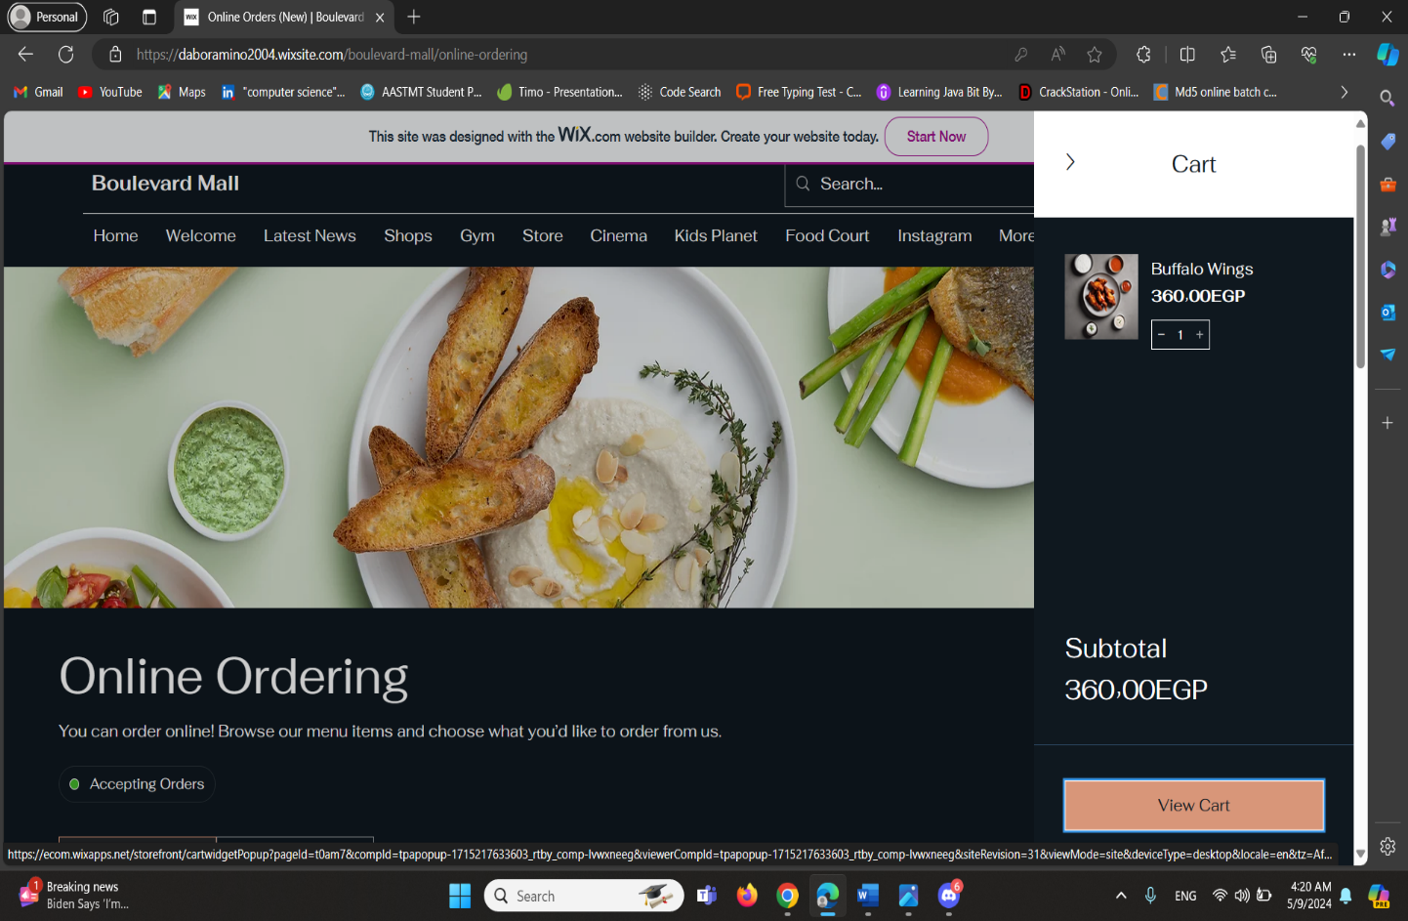

**Our website:** https://daboramino2004.wixsite.com/boulevard-mall

**Chapter 5**

**Conclusion**:

Our mall management system has proven to be efficient and beneficial for all stakeholders involved. It has enabled smoother operations, better customer service, and improved financial management. The system's ability to handle multiple functions such as order tracking, maintenance scheduling, security monitoring, and financial reporting has significantly enhanced the operational efficiency of the malls. The system has also provided a platform for tenants to reach a wider customer base and manage their inventory effectively.

**Future work:**

Looking ahead, we see vast potential for further development and enhancement of our mall management system, and we can use AI in this:

AI can power AR applications that enhance the shopping experience. Customers could try on clothes virtually or navigate the mall.

Predictive maintenance algorithms can anticipate and address facility issues before they arise.

We also aim to enhance our security features by integrating facial recognition technology to ensure a safer environment.